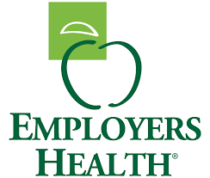

Employer purchasing power is necessary in today’s pharmacy benefit marketplace. That’s why Employers Healthcare Coalition has chosen to collaborate with Employers Health to bolster the size and scale of its solution and deliver a market leading PBM arrangement.
Since 1995, Employers Health’s collective strategy for pharmacy benefits has had a proven track record of delivering aggressive financial performance for its clients. By engaging with best-in-class suppliers – CVS Caremark, OptumRx and Elixir – and having an objective opinion separate from those suppliers, the Employers Health PBM program provides market-leading pricing and terms, while protecting each plan’s unique features. Participating plan sponsors achieve better outcomes through improved adherence and compliance, better experiences via high levels of loyalty and satisfaction and better costs with a consistently flat to negative per capita trend.

The program at a glance:
- 215+ individual plan sponsors
- Covers more than 1 million lives in all 50 states.
- Collectively spends more than $1.5 billion on pharmacy.
- A dedicated client solutions team from the coalition to ensure the PBM relationship is meeting/exceeding expectations.
- Oversight by coalition clinical and analytics teams – pharmacists and actuaries - to monitor new drug launches, analyze trends and provide you and your team with proactive and clinically-sound plan design strategies.
- Annual market check negotiations ensure your plan benefits from updated pricing and contractual terms.
- Claims audit ensures the PBM is compliant with the contract and provides evidence to fulfill a plan sponsor’s fiduciary responsibilities.
- Contract performance management, including reconciliations of performance guarantees, rebates, and pricing guarantees.
- An employer-led board of directors.
- A contract evaluated by independent consultants more than 100 times each year - there’s no self-dealing and contract terms aren’t hidden.

The Employers Health PBM program, delivered through CVS Caremark, covers approximately 1 million lives in all 50 states and is responsible for more than $1.4 billion in prescriptions each year. Advantages include:
- Highest loyalty / satisfaction scores in coalition book of business.
- Dedicated account team with strategic oversight.
- Review of high-cost claims on a weekly basis.

- A focus on keeping participants happy, through a host of proactive vendor management initiatives and participant satisfaction surveys.
With the nation’s premier employer coalition with more than two decades of experience in managing group purchasing arrangements paired with the industry’s most flexible pharmacy care services model, you get a simplified experience, healthier outcomes, and smarter pharmacy care. Why Employers Health and OptumRx?
- 100% client satisfaction for 2018 implementation.
- Real-time alternative medications, authorizations, accurate patient cost by pharmacy and benefit coverage and clinical alerts.
- Flexible plan options, including various network, formulary, and clinical management opportunities to maintain client autonomy.
- Implementation support and proactive management among the plan, its consultant, EH, and OptumRx creating a high retention and satisfaction rating.
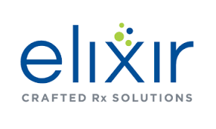
The Employers Health and Elixir relationship provides a visibly different alternative to help you manage rising health care costs. Elixir’s unique pass-through pricing model offers you all negotiated drug discounts and rebates, while benefiting from the added support provided by the Employers Health team. Value-added benefits with Employers Health and Elixir include:
- 100% pass-through pricing.
- Clear contract definitions with sensible guarantees.
- Full to á la carte services.
- Individualized care with condition-focused clinical controls.
- Value over volume.

