Our Keynote Speaker – April 2018

Dr. Scott Conard, M.D., Corporate Healthcare Strategist & Advisor

Scott Conard, MD, DABFM, FAAFP is passionate about transforming healthcare to provide more convenience, significantly improve quality, and lower cost. He believes challenges can best be met with innovation, technology and accountability, and that “greater convenience, higher quality and lower costs” are not mutually exclusive. In fact, the surest path to reduced costs lies in a better model of care that embraces preventive care, early detection, excellence in management of known conditions and improved behaviors.

Scott is a seasoned professional with a history of getting things done. His experience includes efforts such as:

- Organizing physicians and health systems for a 500+ physician medical group
- Designing processes and systems to deliver streamlined care for integrated physician systems
- Identifying and evaluating innovative programs like Naturally Slim to prevent diabetes
- Increasing transparency and employee empowerment with programs like Compass Healthcare.

As the leader of Converging Health, he believes that every company has a unique culture and needs to create opportunities to achieve significant improvement in health and lower costs. His experience in medicine, corporate leadership, and healthcare allows him to create the strategic plan and serve as the accountability "agent", leveraging this deep understanding as an integrator of effective interventions.

Our Panelists – April 2018

Dr. Alan Richardson, M.D. is board certified by the American Board of Family Medicine and practices medicine at the Knapheide Family Wellness Center for WeCare TLC.

Dr. Richardson received his undergraduate degree at Augustana College in Rock
Island, Illinois and his medical degree from the University of Iowa College of Medicine. He completed his residency in family practice at the Southern Illinois University Quincy Family Practice program in Quincy. Before coming to WeCare TLC, he practiced at Blessing Physician Services for 7 years. Prior to that he had practiced in Charleston, Illinois and at the Quincy Medical Group.

In late 2015, Dr. Richardson joined WeCare TLC to provide medical care at the Knapheide Family Wellness Center, serving employees and families of Knapheide Manufacturing here in Quincy, IL.

Jim Baxter is the lead negotiator for the Teachers' Coalition on Health. He has lengthy background as a union/management mediator assisting parties find cost savings in healthcare to finance wage growth. He began his career at American Airlines as a union steward and evolved into a position in corporate finance and risk management. He has a specialized in technology development to create transparency in the pricing of healthcare services. This technology is undergoing testing on a national basis by one of the largest Public Sector Purchasing Coops in the country- NJPA. This technology was utilized by the largest school district health trust in the state to secure Reference Pricing. Quincy Public Schools is a member of that Trust.

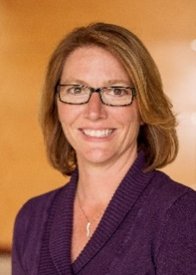
Lisa Sanders is the Director of Total Rewards at McCarthy Holdings, Inc. a 100% employee-owned construction company headquartered in St. Louis, MO. McCarthy celebrated 150 years in 2014. In her role, Lisa is focused on compensation and benefits strategy, wellness and benefits administration.

Lisa has over 20 years of experience in Human Resources with several notable companies including Citigroup, Sara Lee and Spectrum Healthcare. Lisa holds a B.S. in Business Administration from Maryville University and a Masters in Human Resources Management from Webster University.

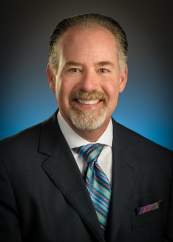
Shane Wolverton, Senior Vice President, Corporate Development | Quantros, Inc.

Shane is responsible for establishing business partnerships for the company and is a sought after speaker on a wide range topics around value-based healthcare delivery. With over 25 years of deep domain expertise in the use of clinically and risk-adjusted medical analytics he works with many stakeholders in health care including employers, brokers, benefits consultants, vendors & providers. He is currently working with numerous organizations leading the movement towards value based care through high performance networks, COEs, transparency, consumer navigation, bundles of care and network optimization. In addition, he advises hospitals, and physicians, in the use of advanced analytics to drive clinical performance improvement, clinical documentation improvement and performance based marketing communications. Prior to joining Quantros, Shane served as founder & senior vice president of corporate development at Comparion Medical Analytics. He also served as a management consultant with Health Care Investment Analysts (now IBM Watson Health) and the McGraw-Hill Healthcare Management Group. Shane received his undergraduate degree from Auburn University.

